**Transition Task 2 - Keeping Safe**

In this task we will be looking at **how you can keep yourself safe** on your journey to and from school.

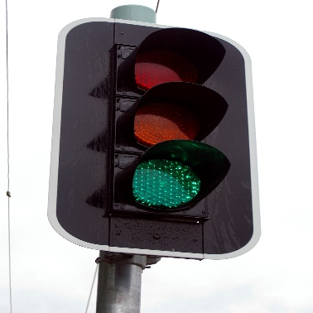

Are there any roads you need to cross?

How will you stay safe when you cross these?



What time do you need to set your alarm clock to get you up in time?

What time do you need to leave the house each morning?

Do you need to catch a bus or train?

What should you do if you miss it?



What should you do if you need to contact your parents or carers during the day?

What should your parents/carers do if they need to contact you?

What should you do with your phone during the school day?



Are you allowed to go to the shop before or after school?

How will you keep your money safe?

Your rules to keep yourself safe

Talk to your family about how you will keep yourself safe on your way into and on your way home from school each day.

**Write 5 rules to help you stay safe**