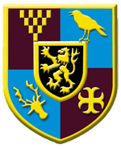**Transition Task 3 – Uniform**

Your school uniform in secondary school will probably feel and look very different to what you have been used to in primary school.

Use information from the school website to find out what your new uniform will be like. How is it different to you old uniform? **Draw the new school uniform** on the person below and make a list of the items you will need.

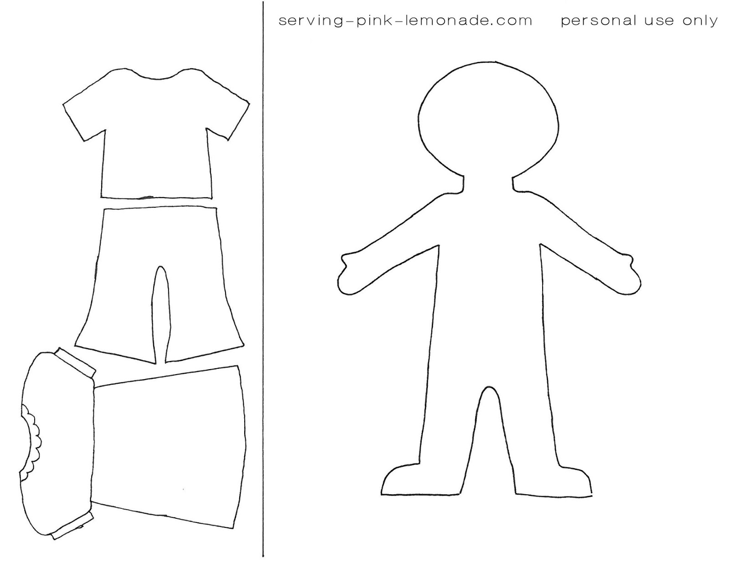

**I will need:**

**Uniform**

****All schools have a uniform of one type or another and they are used for lots of different reasons. We may not always like wearing uniform but it can be helpful to remind ourselves why we need to do so.



**How do you feel about your uniform?**

What I don’t like about school uniform

What I like about school uniform