**Transition task 1- Your journey**

This week’s transition activity is designed to support you with your journey to school.

Your secondary school is likely to be further away than your primary school.

***How do you plan to make your way to school?***

There are a lot of online tools you can use to help you plan your journey:

***https://www.google.co.uk/maps –*** *use this to find directions between two locations.*

***https://www.merseytravel.gov.uk*** *– use this to look at train or bus times. They also have an app you can download to your phone, this will help you find the most appropriate route for your journey.*

*You can also check out the* ***school information about the school bus*** *and the routes it serves.*

(You are not allowed to say I’m getting in the car and the sat nav will tell me! ☺ )

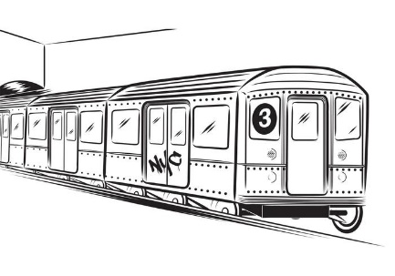



**Use the document on the next page to plan your journey**



**Now plan your journey.**

**Add timings to your notes so you know how long each stage will of your journey will take.**